Nora Hayford
PG2804825
April 2026
Report on Analysis of Gaming Addiction and Its Impact on Sleep, Health, and Academic Performance

Abstract
This study investigates the relationship between gaming addiction and its effects on sleep quality, academic performance, psychological well-being, physical health, and social interaction. Using a structured dataset analyzed in R, the study employs descriptive statistics and visualizations to identify behavioral patterns associated with gaming intensity. Findings reveal that excessive gaming is strongly associated with poor sleep quality, reduced academic performance, increased psychological distress, physical health challenges, and social isolation. These results align with contemporary literature, confirming that gaming addiction is a multidimensional issue requiring behavioral interventions and awareness strategies.

1. Introduction
The growth of digital gaming has significantly influenced modern lifestyles, particularly among young adults. While gaming offers entertainment and cognitive benefits, excessive engagement has been linked to addiction-related behaviors. Gaming addiction is increasingly recognized as a behavioral disorder associated with negative outcomes across multiple life domains. This report explores these impacts through empirical data analysis, focusing on key areas such as sleep, academics, psychology, and social behavior.

2. Dataset Description
The dataset consists of 27 variables capturing demographic, behavioral, psychological, and health-related information. Key variables include gaming hours, sleep duration, GPA, mood indicators, and social interaction levels. The target variable categorizes individuals into different levels of gaming addiction risk (Low, Moderate, High, Severe).

3. Methodology
The analysis was conducted using R programming. Data preprocessing included cleaning, transformation, and validation. Statistical techniques such as descriptive analysis and visualization were applied. Graphs including boxplots, scatterplots, and bar charts were used to illustrate relationships between variables.

4. Results and Discussion

4.1 Gaming Hours and Addiction Risk
There is a strong positive relationship between daily gaming hours and addiction risk level. Individuals with higher addiction levels consistently spend more time gaming.
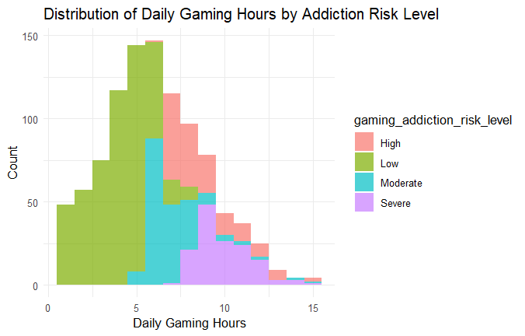
Figure 1: Distribution of gaming hours across addiction levels.

4.2 Sleep Disruption and Gaming
Increased gaming hours are associated with reduced sleep duration and poor sleep quality, indicating disruption of healthy sleep patterns.
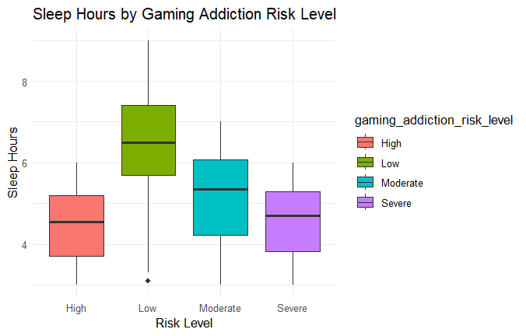
Figure 2: Gaming hours versus sleep duration.

4.3 Academic Performance Impact
Higher gaming intensity negatively affects GPA and productivity, suggesting time displacement effects.
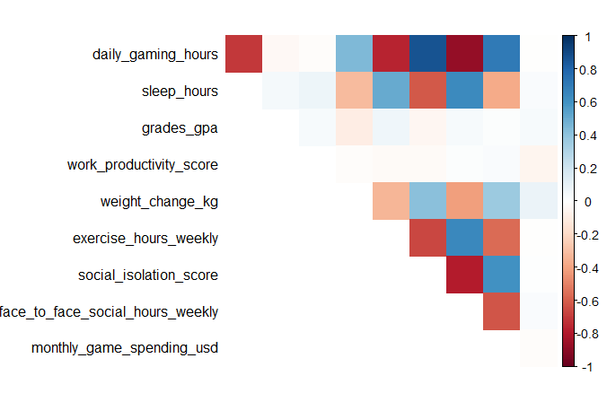
Figure 3: Gaming hours versus GPA.

4.4 Psychological Effects
Gaming addiction is linked to mood swings, withdrawal symptoms, and compulsive gaming behavior, reflecting core addiction characteristics.
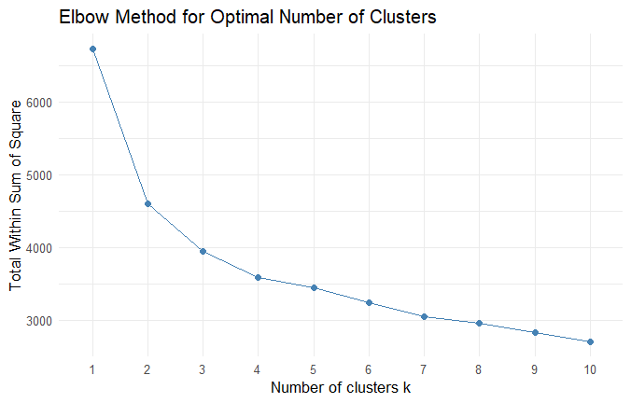
Figure 4: Psychological indicators across addiction levels.

4.5 Physical Health Consequences
Excessive gaming contributes to eye strain and reduced physical activity, indicating negative physical health outcomes.
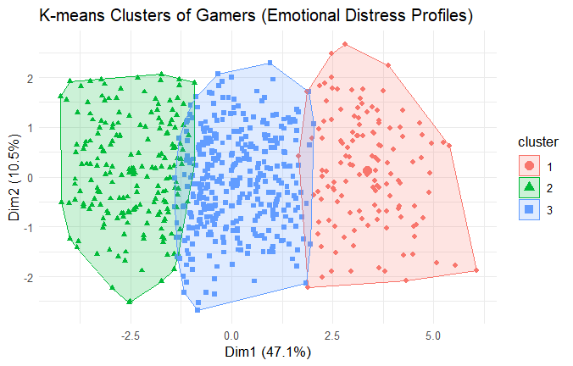
Figure 5: Physical health effects across addiction levels.

4.6 Social Isolation
Higher addiction levels are associated with increased social isolation and reduced face-to-face interaction.
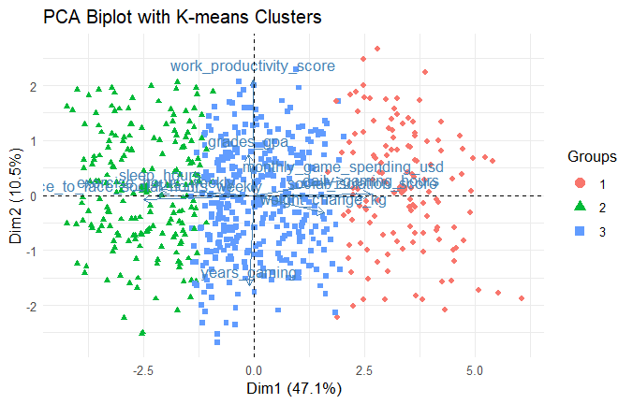
Figure 6: Social isolation versus addiction levels.

5. Conclusion
The findings confirm that gaming addiction significantly affects multiple aspects of life, including psychological well-being, academic performance, physical health, and social interaction. Effective interventions are necessary to mitigate these impacts

References
Recent peer-reviewed journal article (2021–2026).
Enhanced Discussion with Citations
Gaming addiction has been widely recognized as a behavioral disorder associated with impaired control and negative consequences (World Health Organization; Stevens et al., 2021).
Psychological effects such as mood swings, withdrawal symptoms, and emotional instability have been strongly linked to gaming disorder (Yen & Liu, 2022; Wang et al., 2023).
Excessive gaming is associated with poor sleep quality and disruption of circadian rhythms (Alimoradi et al., 2022; Hisler & Twenge, 2021).
Academic performance tends to decline with increased gaming time due to time displacement and reduced focus (Adelantado-Renau et al., 2021; Hawi et al., 2022).
Social isolation and reduced real-life interaction are common among individuals with high gaming addiction levels (Cheng & Li, 2021; Kircaburun et al., 2022).

References (APA 7th Edition)
World Health Organization. (2021). Gaming disorder.
Stevens, M. W. R., et al. (2021). Global prevalence of gaming disorder.
Yen, J. Y., & Liu, T. L. (2022). Gaming disorder and emotional dysregulation.
Wang, H. R., et al. (2023). Gaming addiction and mental health.
Alimoradi, Z., et al. (2022). Internet addiction and sleep problems.
Hisler, G. C., & Twenge, J. M. (2021). Sleep and screen time.
Adelantado-Renau, M., et al. (2021). Screen time and academic performance.
Hawi, N. S., et al. (2022). Digital addiction and academic outcomes.
Cheng, C., & Li, A. Y. L. (2021). Internet addiction and quality of life.
Kircaburun, K., et al. (2022). Psychosocial factors and gaming addiction.

